300A Connector Specification 03
 | Juheng technologies co. Ltd |  | Lithium battery module connector
Ⅰ、Product appearance
Positive pole:JH-LJ-300-03-A  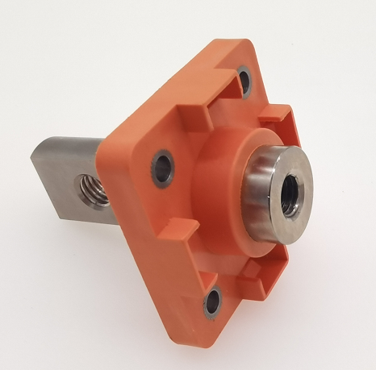  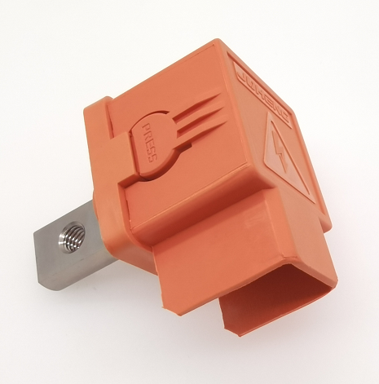 |  | Negative pole:JH-LJ-300-03-B  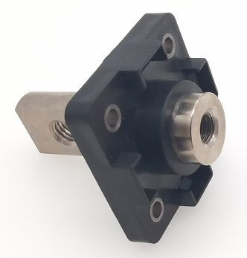  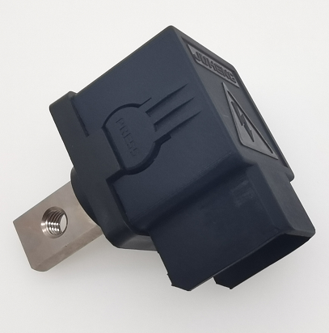
Ⅱ、Performance parameter：
1、Electrical parameters
■ Rated Voltage：1500V DC
■ Rated current：300AMP
■ Withstand voltage：4200V DC
■ Insulation Resistance：≥500MΩ
■ Contact Resistance：≤0.5mΩ

2、Mechanical parameter
■ Contact surface diameter：18mm
■ Screw bore diameter：M8
■ Tightening torque: M8 Threaded hole (Coarse thread)：12N.m MAX

3、Materials composition
■ Conductor: T2 copper, nickel plated
■ Insulating material：PA66 Flame retardant V0 Level
■ Insulation parts thermal deformation temperature：205℃
■ Color：Positive pole orange color / Negative pole black color
■ Sealing ring: silicone

Ⅲ、External dimension
Units：mm

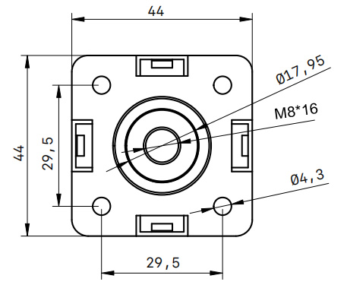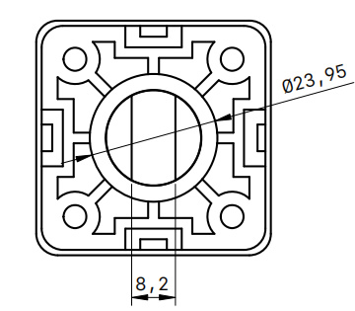

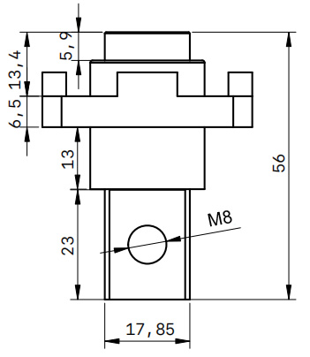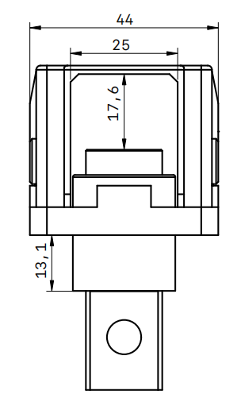

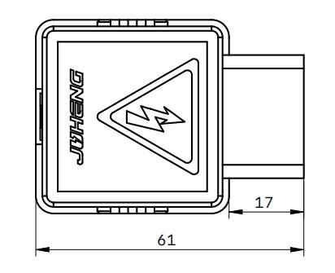

Ⅳ、Installation trepanning
- Units:mm
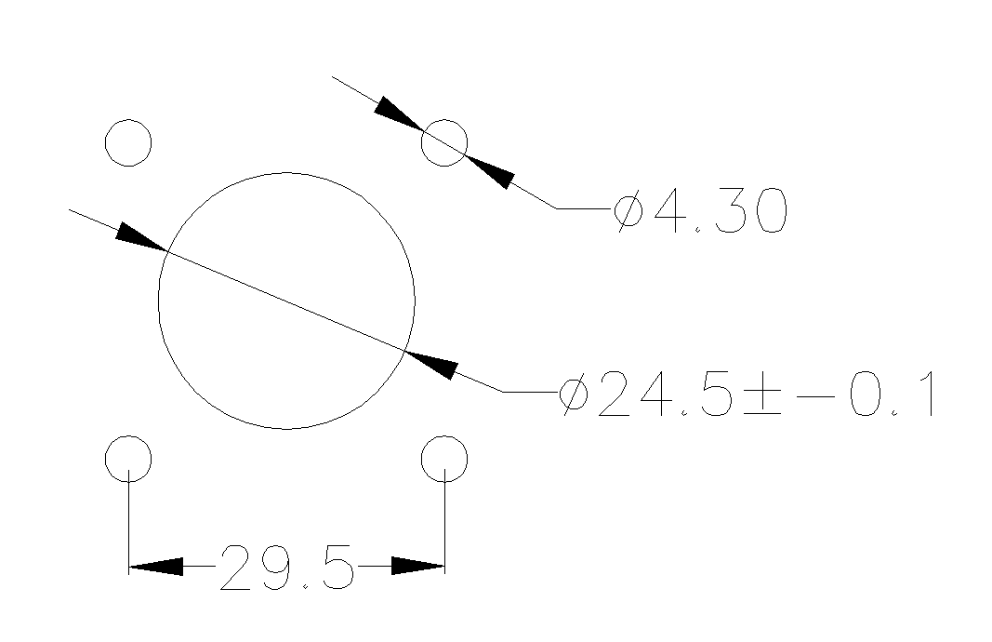

20220830 Juheng technologies co. Ltd

